23AI2003 –Artificial Intelligence for Web Development Lab
URK23CS5003

Ex. No: 10 | Design and Development of a Responsive Website using AI Tools

Aim

To design and develop a responsive website using AI-powered tools for generating layout, content, and code efficiently.

Description

The application involves designing a responsive website using various AI-powered tools to assist in layout creation, content generation, and code development. AI tools such as ChatGPT, GitHub Copilot, and design platforms like Canva or Figma are used to generate HTML structure, CSS styling, and JavaScript functionality. The website includes multiple pages such as Home, About, Services, and Contact, and incorporates responsive design techniques to ensure compatibility across different devices. Dynamic features are added using JavaScript to enhance interactivity. The use of AI tools helps in improving productivity, reducing development time, and enhancing design quality. This experiment demonstrates the integration of artificial intelligence in modern web development processes.

Code
Index.html
<!DOCTYPE html>
<html>
<head>
<title>My Portfolio</title>
<link rel="stylesheet" href="style.css">
</head>
<body>

<header>
<h1>Welcome to My Portfolio</h1>
<p>I am Evangeline - Web Developer</p>
</header>

<nav>
<a onclick="showSection('home')">Home</a>
<a onclick="showSection('about')">About</a>
<a onclick="showSection('services')">Skills</a>
<a onclick="showSection('contact')">Contact</a>
</nav>

<section id="home" class="section">
<h2>Home</h2>
<p>This website is created using AI tools like ChatGPT.</p>
<button onclick="showMsg()">Click Me</button>
</section>

<section id="about" class="section">
<h2>About Me</h2>
<p>I am a passionate student with strong interest in Web Development and Artificial Intelligence.</p>
<p>I enjoy building creative websites and exploring new technologies.</p>
<p>My goal is to become a skilled full-stack developer.</p>
</section>

<section id="services" class="section">
<h2>My Skills</h2>
<ul>
<li>HTML, CSS, JavaScript</li>
<li>Java Programming</li>
<li>Database (MySQL)</li>
</ul>
</section>

<section id="contact" class="section">
<h2>Contact</h2>
<p>Email: evangeline@karunya.edu.in</p>
</section>

<script src="script.js"></script>

</body>
</html>

Script.js

function showMsg() {
alert("Welcome! This portfolio is created using AI tools.");
}

function showSection(sectionId) {
let sections = document.querySelectorAll(".section");

sections.forEach(section => {
section.style.display = "none";
});

document.getElementById(sectionId).style.display = "block";
}

// Show home section by default
window.onload = function() {
showSection('home');
}

Style.css

body {
font-family: 'Segoe UI', sans-serif;
margin: 0;
background: linear-gradient(to right, #667eea, #764ba2);
color: white;
text-align: center;
}

header {
padding: 30px;
}

nav {
background: rgba(0,0,0,0.3);
padding: 15px;
}

nav a {
color: white;
margin: 15px;
cursor: pointer;
font-weight: bold;
}

nav a:hover {
color: #ffd700;
}

.section {
display: none;
background: rgba(255,255,255,0.1);
margin: 20px;
padding: 30px;
border-radius: 15px;
}

button {
padding: 10px 20px;
background: #ffd700;
border: none;
color: black;
cursor: pointer;
border-radius: 5px;
}

button:hover {
background: #ffcc00;
}

ul {
list-style: none;
}

@media (max-width: 600px) {
nav a {
display: block;
margin: 10px;
}}

Input & Output
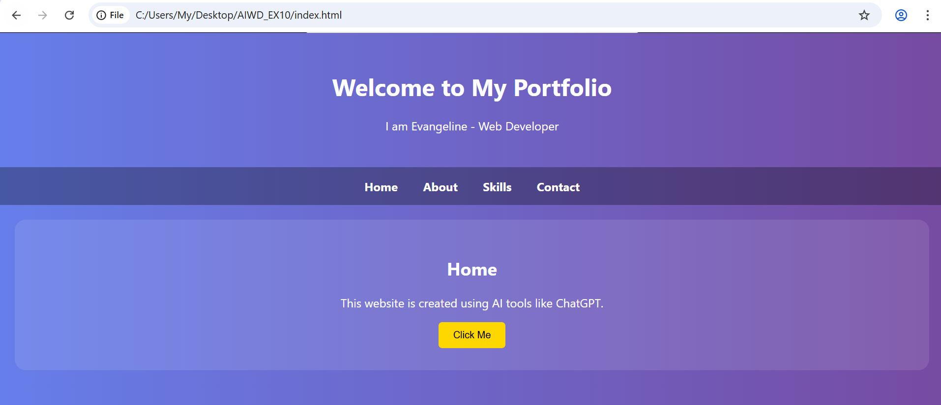
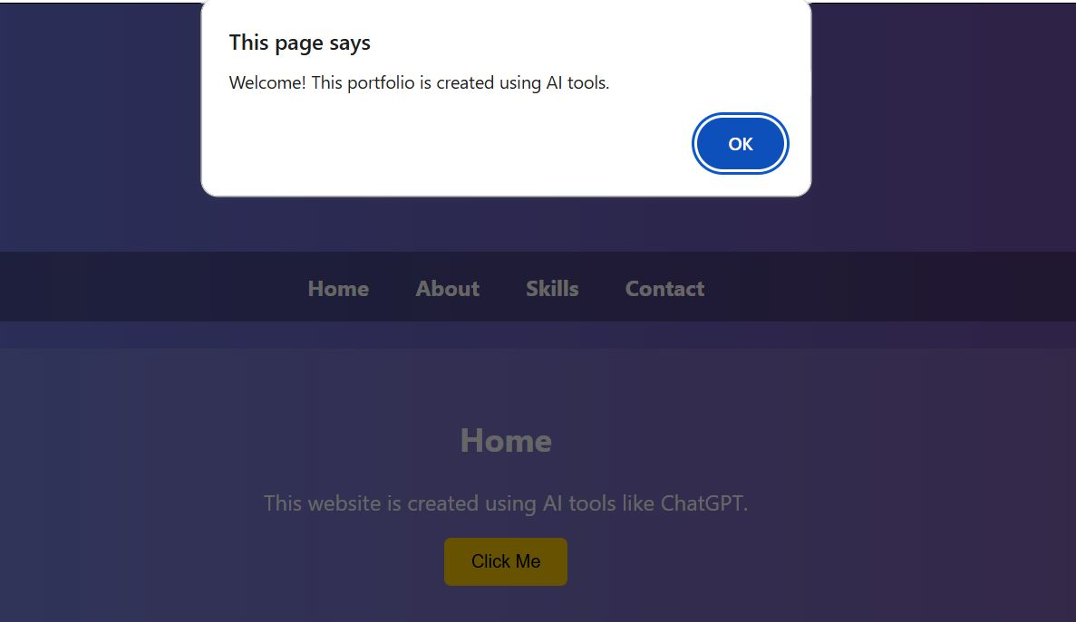

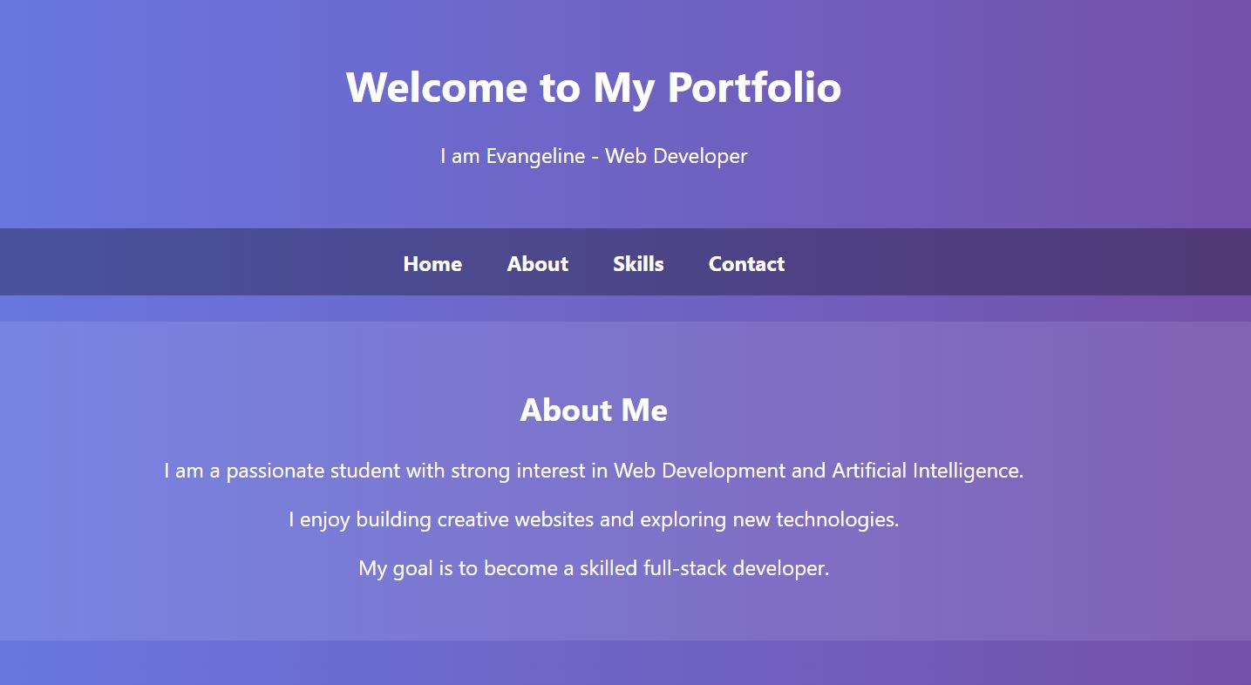
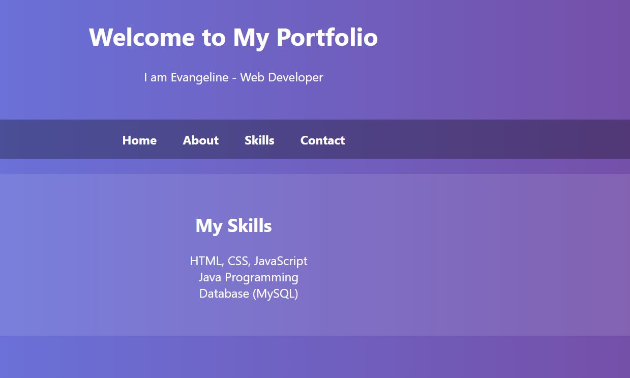

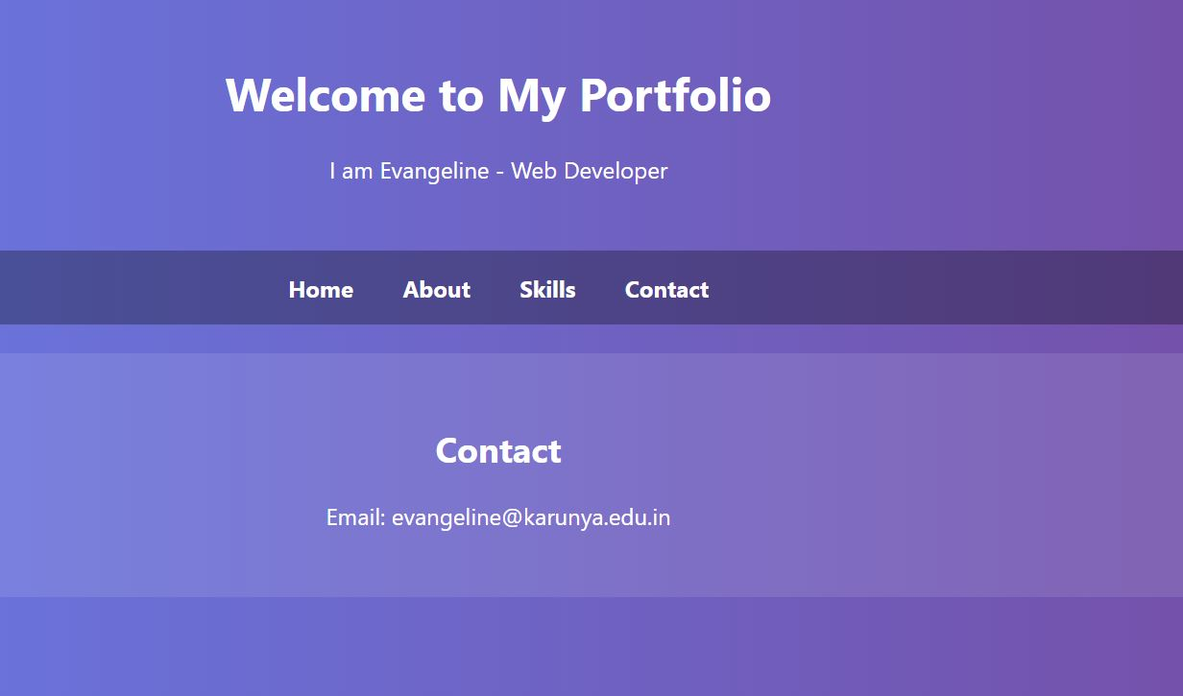

Result
The responsive website was successfully designed and developed using AI tools, demonstrating effective layout generation, content creation, and dynamic functionality.

